Executive Lease Agreement
This Executive Rental and Lease Agreement (the "Lease") is made between _________________________ whose principal office is located at __________________________________________________________________________; herein called "Lessee," and _________________________, situated at _________________________, herein called "Lessor.
WHEREAS Lessee hereby offers to lease from Lessor rooms for corporate meetings;
WHEREAS Lessor leases needed space for corporate executives on an as-needed basis;
In consideration of the covenants and conditions hereinafter set forth and other good and valuable consideration, the receipt and sufficiency of which is hereby acknowledged, the parties agree to enter into this Lease as follows:
- Grant of Lease.
Lessor hereby leases unto Lessee, and Lessee hereby rents from Lessor, the real property located at __________________________________________________ (the "Premises"),
- Term and Rent.
Lessee agrees to lease the above Premises for a term of one (l) year commencing _________________________ with an option to renew on _________________________, and each year thereafter, at the daily rental rate of $500.00, or such other amount as is determined to be in accordance with the fair market rate of the space leased at the time, payable in advance of the reserved period.
The minimum rental period shall be one (l) day, equivalent to eight (8) hours. After the first day, it is possible to rent for a half day of four (4) hours, prorated to half of the daily rental rate.
Each full day of rental will include up to eight (8) hours of usage of the leased space. If more hours are needed, they will be charged at $100.00 per hour.
During the term of this Lease, all rental payments shall be made to _________________________ , Lessor, at the address specified above.
During the term of this Lease, the Lessor agrees to supply the following:
- Conference / Meeting Room
- Common areas including restrooms
- Entertainment areas including kitchen and dining room
- Furniture, including, but not limited to, conference table and chairs for each participant
- Beverage/Meal Service
- Computer Access
- LCD Projector
- Network Connection
- TV/DVD Player
- Video Conferencing
- Whiteboard
- Wireless Internet
All meals, snacks, and beverages are provided by the Lessor.
Any additional food and entertainment are the Lessee's responsibility.
Any entertainment plans or food preparation on site must be discussed with the Lessor fifteen (15) days before the meeting occurs.
- Use.
Lessee shall use and occupy the Premises for Executive, Employee, Client, and reoccurring corporate meetings for marketing, entertainment, and corporate compliant purposes. The Premises shall be used for no other purpose. Lessor represents that the Premises may lawfully be used for such purpose.
- Notice.
Lessee shall provide Lessor with as much notice as possible to ensure that the space will be available. Notice may be in any written form, including electronic, and must include the dates and times of use requested, as well as the number of persons to be present.
Failure to provide sufficient notice may result in Lessee having to reschedule use for an alternative date on which the Premises are available.
Upon receiving Lessee's notice of intention to rent the Premises, Lessor shall respond to Lessee within twenty-four (24) hours with either a confirmation of rental or proposition of alternative dates on which the Premises will be available.
- Care and Maintenance of Premises.
Lessor acknowledges that the Premises are in good order and repair, unless otherwise indicated herein. Lessor shall, at his/her own expense and at all times, maintain the Premises in good and safe condition, including plate glass, electrical wiring, plumbing, heating and cooling, and any other system or equipment on the Premises.
Lessor shall be responsible for preparing the Premises for meetings and entertainment gatherings as follows:
  - Interior area to be used for corporate meetings and entertainment, including main entertainment room, bathroom, kitchen and dining area, to be cleaned and ready prior to the event.
  - Exterior: sidewalks, driveways, lawns and shrubbery, which should be groomed accordingly and visually acceptable to Lessee.
Lessee shall be responsible for preparation of the event, including desired decoration, food and drink preparation, and serving equipment for the guests.
Entertainment hired Lessee must be discussed with the Lessor fifteen (15) days prior to the event.
Lessee shall perform post-event cleaning, pickup, and removal of garbage in the areas as follows:
  - Interior area to be used for corporate meetings and entertainment, including main entertainment room, bathroom, kitchen and dining area.
  - Exterior: sidewalks, driveways, lawns.
Any damages caused to the interior or exterior property by Lessee and/or its guests shall be covered by the Lessee within 30 days of the incident.
- Smoking Policy
No smoking will be allowed inside the building. Lessee and its guests who intend to smoke must do so in designated areas outside the building.
- Insurance.
Lessor has insured the Premises for the intended use contemplated by the terms of this Lease.
- Indemnification.
Lessor shall not be liable for the damage or injury to Lessee or Lessee's guests or invitees on or in the Premises and Lessee hereby agrees to indemnify, defend, and hold Lessor harmless from any and all claims or assertions of every kind and nature arising out of or in connection with this Lease.
- Severability.
If any part or sub-part of this Lease is deemed invalid by court order, judgment, or other operation of law, the remaining parts and sub-parts shall remain valid and enforceable to the fullest extent.
- Governing Law and Jurisdiction
This Lease and all disputes arising under or in connection to it shall be governed by the laws of the State of Michigan and shall be subject to the jurisdiction of the courts of the State of Michigan.
- Counterparts.
This Lease may be executed in counterparts, all of which shall constitute a single agreement.
IN WITNESS WHEREOF the parties to this Lease have duly affixed their signatures under hand and seal, or by duly authorized officer under seal, on this first day of ________________.
By: _________________________, Lessor
Name: ____________________
By: _________________________, Lesee
Officer Name: ____________________
The Inn at Harbor Shores
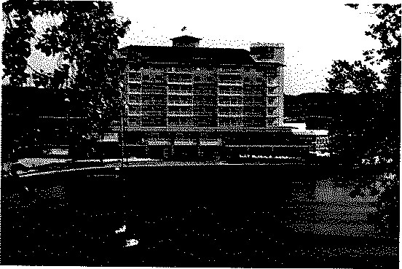
800 Whitwam Dr.
Saint Joseph, Ml 49085
Marina View Boardroom $500.00 per day
Additional Charges:
Snacks, refreshments, and office supplies $100.00 per day
Total: $600.00 per day

Holiday Inn Express & Suites Niles
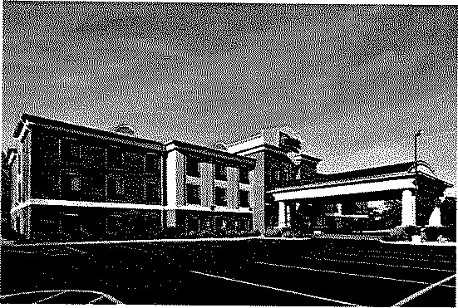
1000 Moore Dr. Niles, Ml 49120
Niles Room
$300.00 per day
Additional Charges:
Snacks, refreshments, and office supplies $100.00 per day
Total: $400.00 per day

AVG = $500.00
TFR Quote = $500.00

WAIVER OF NOTICE OF SPECIAL MEETING OF DIRECTORS
OF
_______________________________
We, the undersigned, being all the Directors of ______________________________. (the "Company"), hereby agree and consent that the Special Meeting of the Board of Directors of the Company be held on the date and time and at the place designated hereunder, and do hereby waive all notice whatsoever of such meeting and of any adjournment or adjournments thereof.
We do further agree and consent that any and all lawful business may be transacted at such meeting or at any adjournment or adjournments thereof, the Directors present may deem as advisable thereat. Any business transacted at such meeting or at any adjournment or adjournments thereof shall be as valid and legal and of the same force and effect as if such meeting or adjourned meeting were held after notice.
Place of Meeting: _____________________________
Date of Meeting: _____________________________
Time of Meeting: _____________________________
Dated: _____________________________

_________________, Director

MINUTES OF SPECIAL MEETING OF DIRECTORS
OF
_________________________

A special meeting of the directors of ______________________. was held at __________________________________ on __________. The meeting convened at ___________, ________________ presiding, with ____________, Secretary, in attendance. The Secretary announced that the meeting was held pursuant to notice, if and as required under the bylaws of this Company, or that notice had been waived by all Directors entitled to receive notice under the bylaws. Copies of any certificates of mailing of notice prepared by the Secretary of the Company and any written waivers signed by Directors entitled to receive notice of this meeting were attached to these minutes by the Secretary.
Directors in attendance: _____________________________
Others in attendance: _____________________________
Officers' reports:
President: _____________________________
Secretary: _____________________________
Treasurer: _____________________________
Discussion:
- Reviewed and recapped prior year operations
Discussed goals for new year
- Discussed need for payroll tax filings, including 1099s for prior year
A Waiver of Notice signed by all the Directors was presented and ordered by the chairman to be inserted into the Minute Book of the Company immediately prior to the minutes of this meeting.
There were other minor discussions regarding the Company's business along with current financial conditions not recorded here. The meeting was adjourned.
________________, Secretary Date of Approval

